MLA 1

Modern Language Association (MLA) Format and Documentation

This handout covers the basics of MLA format and the documentation of sources students frequently use. For more complete information, refer to the MLA Handbook for Writers of Research Papers, 7th ed. The MLA has a brief FAQ page online at http://www.mla.org/handbook_faq

Formatting Your Paper

• Margins: One-inch on the top, bottom, and sides of each page.

• Page Numbering: Use your word processor to create a header that includes your last name and the page number in the upper right hand corner of the page, one half inch from the top of the page. Every page has this header.

• Title Page: MLA style does not require a title page; instead, the first page of the paper should begin with four lines, double spaced, indicating: your name, name of the course instructor, name of the course, and the date.

• Spacing: Double-space every line (including long quotes and the citations on the Works Cited page).

• Indenting: Indent the first line of every paragraph five spaces or one tab. Indent long quotations ten spaces or two tabs.

• Font and Typeface: Use a 12-point font in Times New Roman

Here is an example:
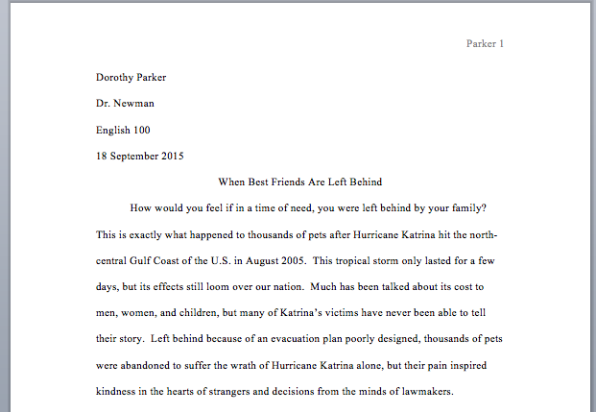
MLA 2
Creating the Works Cited Page

• Continue the page numbering sequence from the main body of your paper.

• Center the words “Works Cited” one inch from the top of the page.

• Continue double-spacing.

• If the citation takes up more than one line of the page, indent the remaining line(s) one-half inch from the left margin.

• Reverse the name of the author: list the author’s last name followed by a comma and the author’s first name.

• Alphabetize the works you cite by the last name of the author. If there is no known author, alphabetize by the first word in the title of the work other than A, An, or The.

Here is an example:

Johnson 12

Works Cited

“Americans Without Work.” Editorial. New York Times. New York Times, 22 Dec. 2009. Web. 23 Dec. 2009.

Didion, Joan. “On Going Home.” The Beacon Book of Essays by Contemporary American Women. Ed. Wendy Martin. Boston: Beacon, 1996. 3-5. Print.

Gould, Elizabeth. “Women Working in Music Education: The War Machine.” Philosophy of Music Education Review 17.2 (2009): 126-143. Project Muse. Web. 23 Dec. 2009.

Gregory, Phillipa. The Other Boleyn Girl: A Novel. New York: Simon, 2001. Print.

Han, Phil. “Jailbreak Fugitive Updates Facebook Page.” CNN.com. Cable News Network, 23 Dec. 2009. Web. 23 Dec. 2009.

Stewart, Maria W. “Two Texts on Children and Christian Education.” PMLA 123.1 (2008): 156-165. Print.

Works Cited 1

Sample Works Cited Page Entries

• A Book by a Single Author

Last name, first name. Title of the Book. City of Publication: Name of the Publisher, year. Medium of publication.

Gregory, Phillipa. The Other Boleyn Girl: A Novel. New York: Simon, 2001. Print.

• An Anthology or a Compilation

Editor’s last name, first name, ed. Title of the Book. City of Publication: Name of the Publisher, year. Medium of publication.

Martin, Wendy, ed. The Beacon Book of Essays by Contemporary American Women. Boston: Beacon, 1996. Print.

• A Book by Two or More Authors

If the book has two or more authors, list their names in the same order they appear on the title page of the book. Reverse only the name of the first author.

Last name, first name, and first name last name. Title of the Book. City of Publication: Name of the Publisher, year. Medium of publication.

Witte, Stephen P., and Lester Faigley. Evaluating College Writing Programs. Carbondale: Southern Illinois UP. Print.

• A Work in an Anthology

Last name, first name. “Title of the Part of the Book Being Cited.” Title of the Anthology. Ed. Editor’s first name last name. City of Publication: Name of the Publisher, year. Page numbers of the cited piece. Medium of publication.

Didion, Joan. “On Going Home.” The Beacon Book of Essays by Contemporary American Women.

Ed. Wendy Martin. Boston: Beacon, 1996. 3-5. Print.

• An Article in a Newspaper or Magazine

Last name, first name. “Title of the Article.” Name of the magazine day abbreviated month year: pages. Medium of publication.

Anderson, Laurie. “Music and Its Effects on One’s Mood.” Time 20 Nov 2013: 25. Print.

• An Article in a Scholarly Journal

Last name, first name. “Title of the Article.” Name of the Journal volume number.issue number (year): page numbers. Medium of publication.

Stewart, Maria W. “Two Texts on Children and Christian Education.” PMLA 123.1 (2008): 156-165. Print.

• A Nonperiodical Web Publication (including web sites sponsored by newspapers, magazines, and news organizations)

Last name, first name. “Title of the Work.” Title of the Overall Web Site. Publisher or Sponsor of the Site, Date of publication. Medium of publication. Date of access.

Han, Phil. “Jailbreak Fugitive Updates Facebook Page.” CNN.com. Cable News Network, 23 Dec. 2009. Web. 23 Dec. 2009.

• A Journal Article in an Online Database

Last name, first name. “Title of the Article.” Name of the Journal volume number.issue number (year): page numbers. Title of the Database. Medium of publication. Date of access.

Gould, Elizabeth. “Women Working in Music Education: The War Machine.” Philosophy of Music Education Review 17.2 (2009): 126-143. Project Muse. Web. 23 Dec. 2009.

Works Cited 2

• Entire Website

Last name, first name (if available). Name of Site. Version number. Sponsor or publisher, Date of creation. Medium of publication. Date of access.

The Purdue OWL Family of Sites. The Writing Lab and OWL at Purdue and Purdue U, 2009. Web. 23 Dec. 2009.

• Page on a Website

Last name, first name (if available). “Title of the Webpage.” Name of Site. Version number. Sponsor or publisher, Date of creation. Medium of publication. Date of access.

“Athlete’s Foot.” WebMD. WebMD, Sept. 2014. Web. 6 July 2015.

• Image on a Website

Artist’s last name, first name. Name of the work of art. Date of creation. Institution, City Name of Site. Medium of publication. Date of access.

Goya, Francisco. The Family of Charles IV. 1800. Museo Nacional del Prado, Madrid. Museo Nacional del Prado. Web. 12 Nov. 2012.

